
Name: Abhishek Singh
PRN: 25070122012
Subject: Programming with Java
ASSIGNMENT No: 1
TITLE: Develop an application based on Java environment setup, JDK/JRE/JVM, variables, methods and constructors. and demonstrate the implementation of the concepts through suitable examples.
Problem Statement
Develop an application based on Java environment setup, JDK/JRE/JVM, variables, methods and constructors. and demonstrate the implementation of the concepts through suitable examples.
Learning Objectives
Understand the theoretical concepts, implement them in Java programs, analyze outputs, and apply the concepts to solve practical programming problems.
Theory
Java environment setup, JDK/JRE/JVM, variables, methods and constructors. forms an important component of Java programming. Students should understand the underlying concepts, architecture, advantages, use cases, and implementation methodology. The exercise should focus on understanding the design principles, coding practices, execution flow, and practical applications of these concepts in software development. Detailed study should include syntax, APIs, execution process, and real-world applications.

Output Screenshot
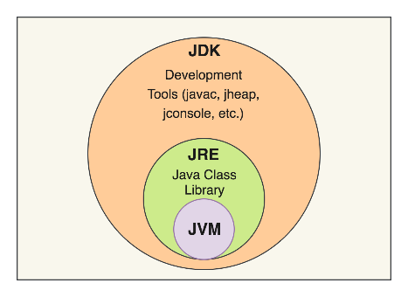
The diagram shows the layered architecture of the Java platform. The JDK encompasses the JRE along with development utilities like javac and jconsole. The JRE, in turn, includes the Java Class Library and the JVM. The JVM forms the innermost component and executes Java bytecode, enabling platform-independent program execution.

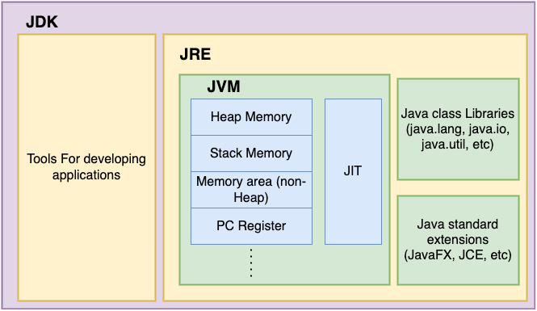
This diagram shows the relationship between the JDK, JRE, and JVM. The JDK includes all the tools required for Java development along with the JRE, while the JRE contains the JVM, Java Class Libraries, and standard extensions needed to execute Java applications. The JVM serves as the core execution engine, managing memory and converting bytecode into machine code using the JIT compiler.
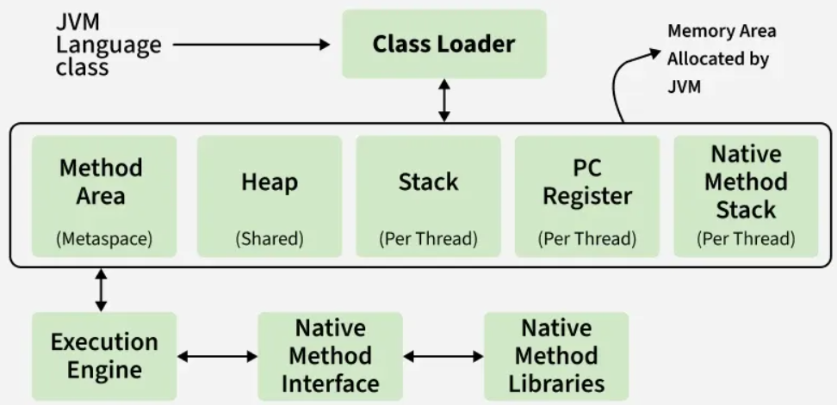
This diagram shows the architecture and execution flow of the Java Virtual Machine (JVM). It illustrates how the Class Loader loads Java classes into the JVM's runtime memory areas—Method Area, Heap, Stack, PC Register, and Native Method Stack—while the Execution Engine executes the bytecode and interacts with native libraries through the Native Method Interface (JNI) to run the application.
Conclusion
In this assignment, I learned how to set up the Java programming environment using the JDK, JRE, and JVM. I understood the role of each component in compiling and executing Java programs. I also learned how to declare and use variables of different data types, create methods to perform specific tasks, and use constructors to initialize objects. By implementing these concepts in Java programs, I gained practical knowledge of object-oriented programming and understood the execution flow of Java applications. This assignment strengthened my programming fundamentals and prepared me for developing more advanced Java applications.
Questions
1. Explain the main concept used in Java environment setup, variables and methods.
The Java environment setup is built around three layered components: the JDK (development tools), the JRE (runtime libraries), and the JVM (execution engine). Together they allow a developer to write, compile, and run Java code, with the JVM ensuring platform independence by executing bytecode on any operating system.

2. What are the real-world applications?
JDK/JRE/JVM architecture powers cross-platform enterprise software, Android app development (via similar runtime concepts), and large-scale distributed systems like banking and e-commerce platforms. Its portability and memory management make it a preferred choice for building scalable, long-running server applications.

